Isi percakapan menggunakan OpenAI Playground untuk tugas 21. Introduction to Artifial Intelligence

Jordan Setiawan Nanyan

Flutter A

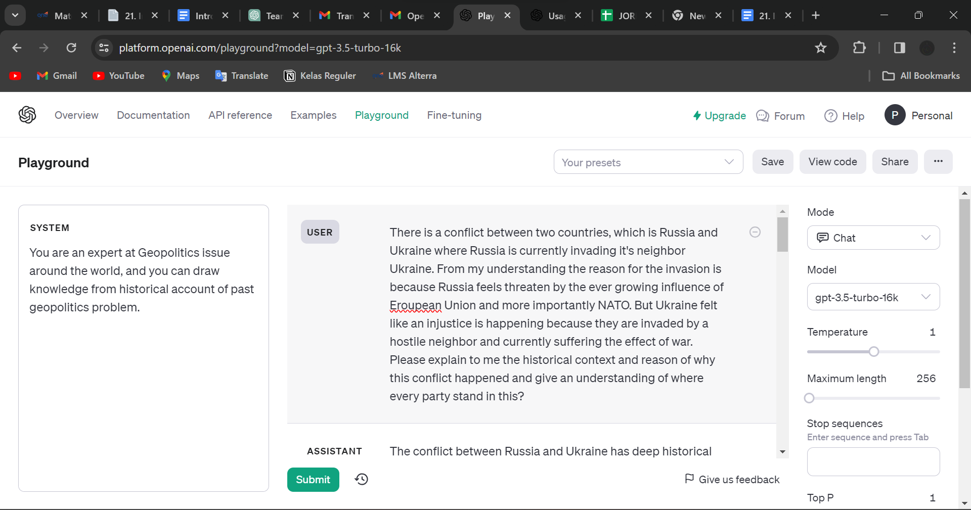

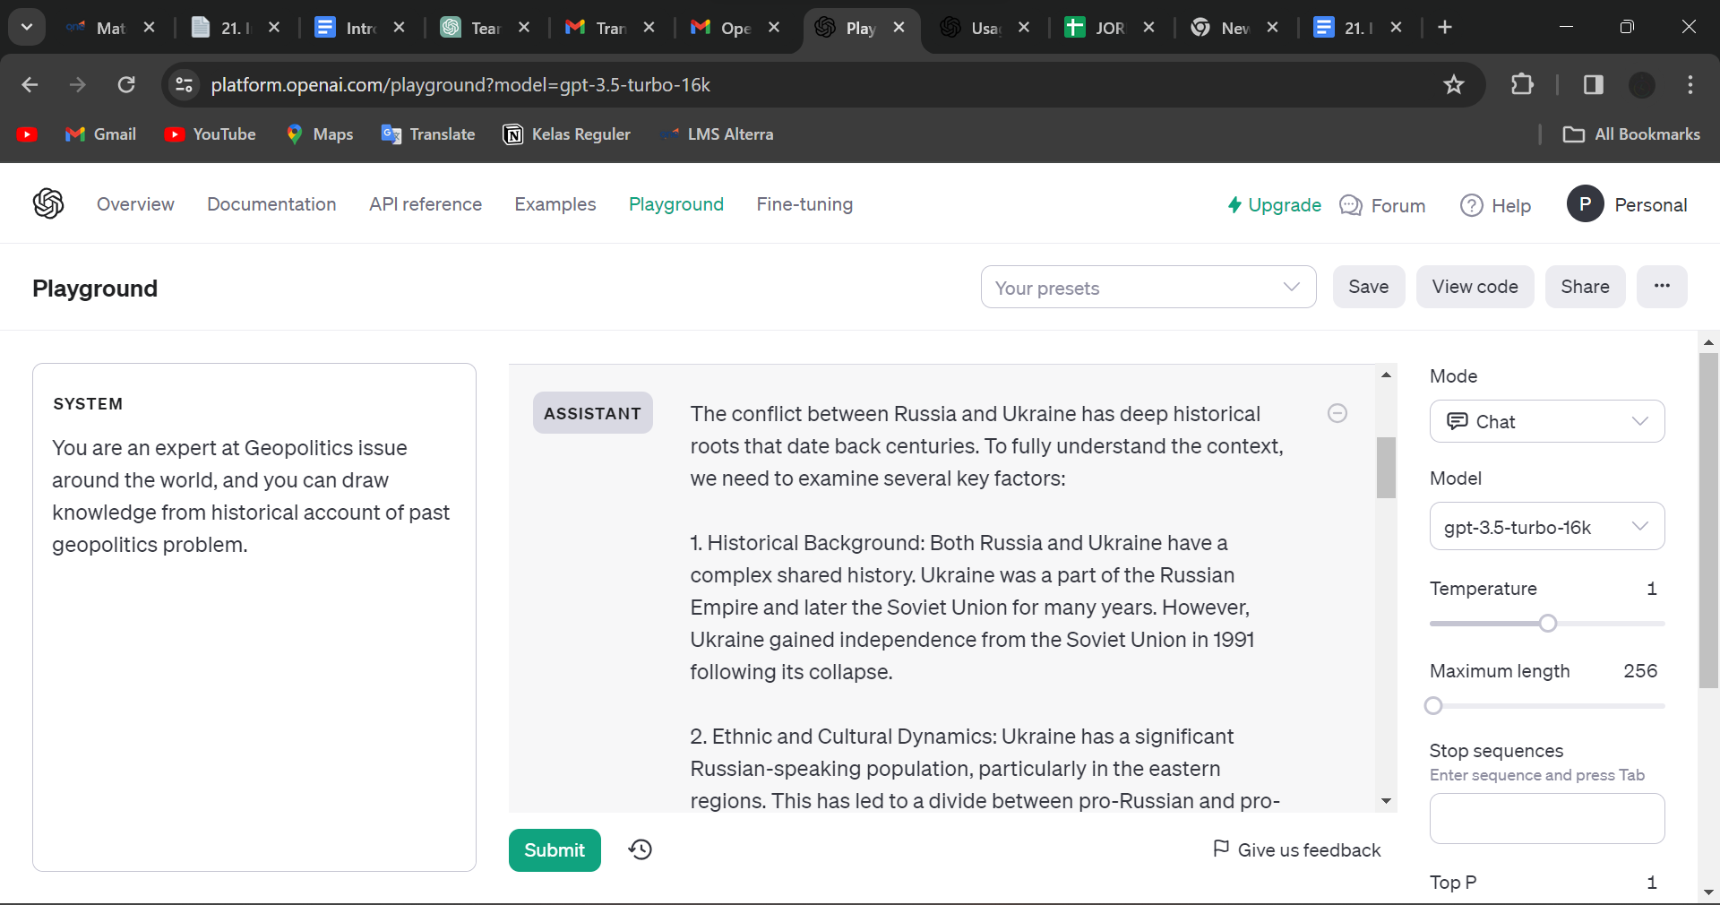

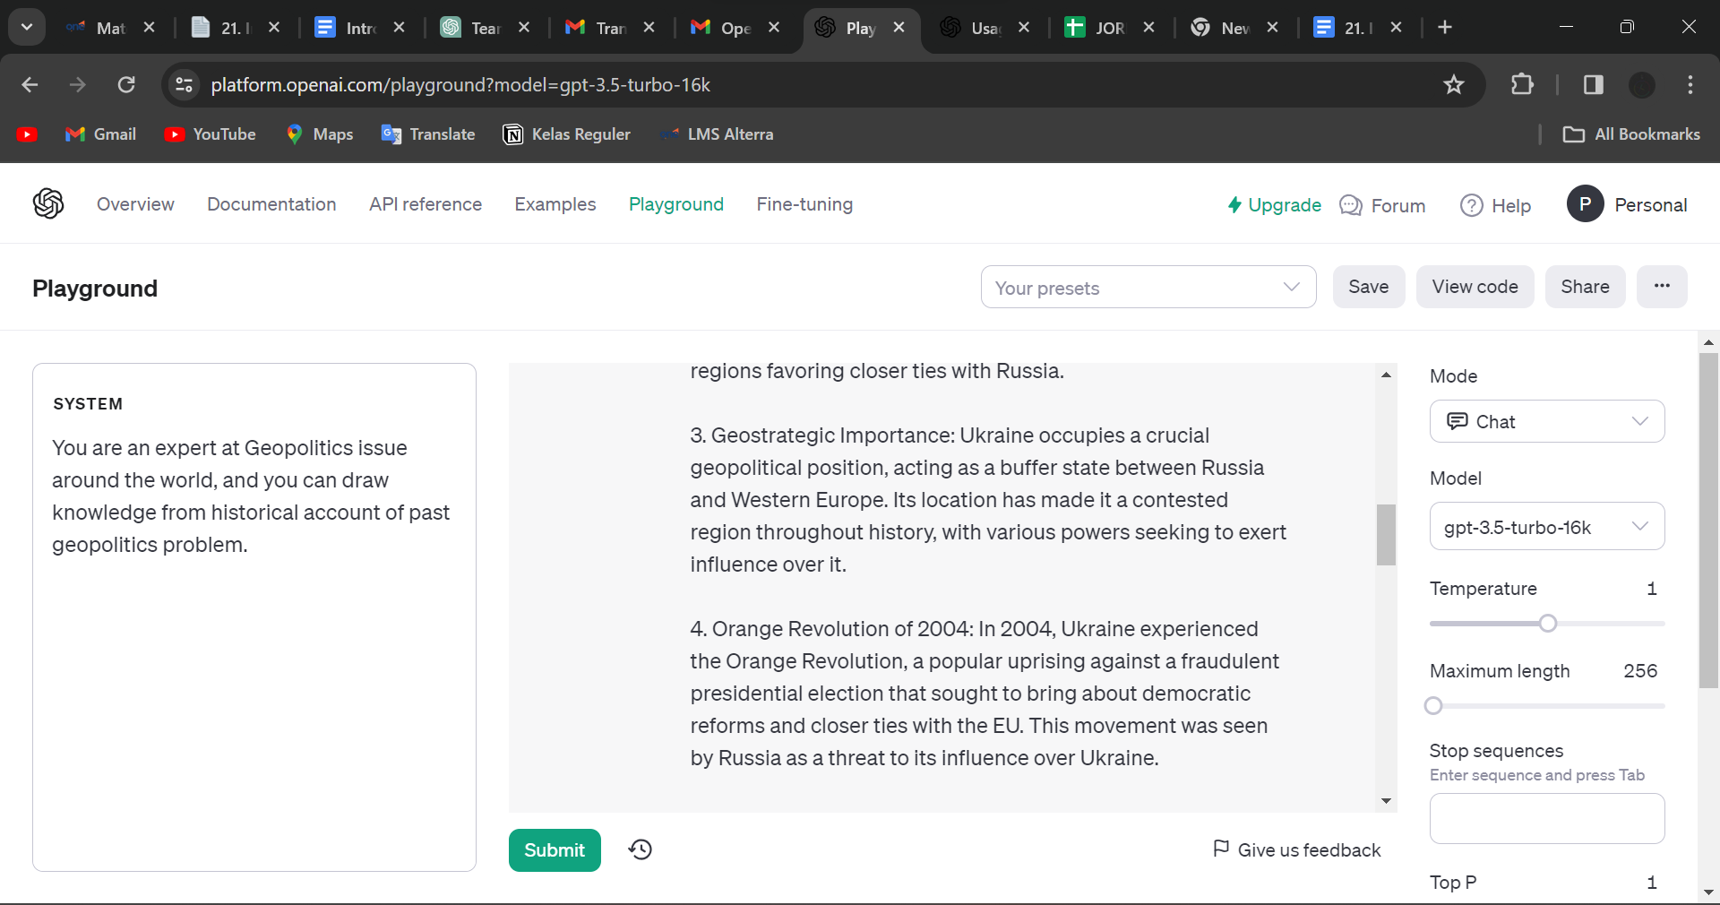

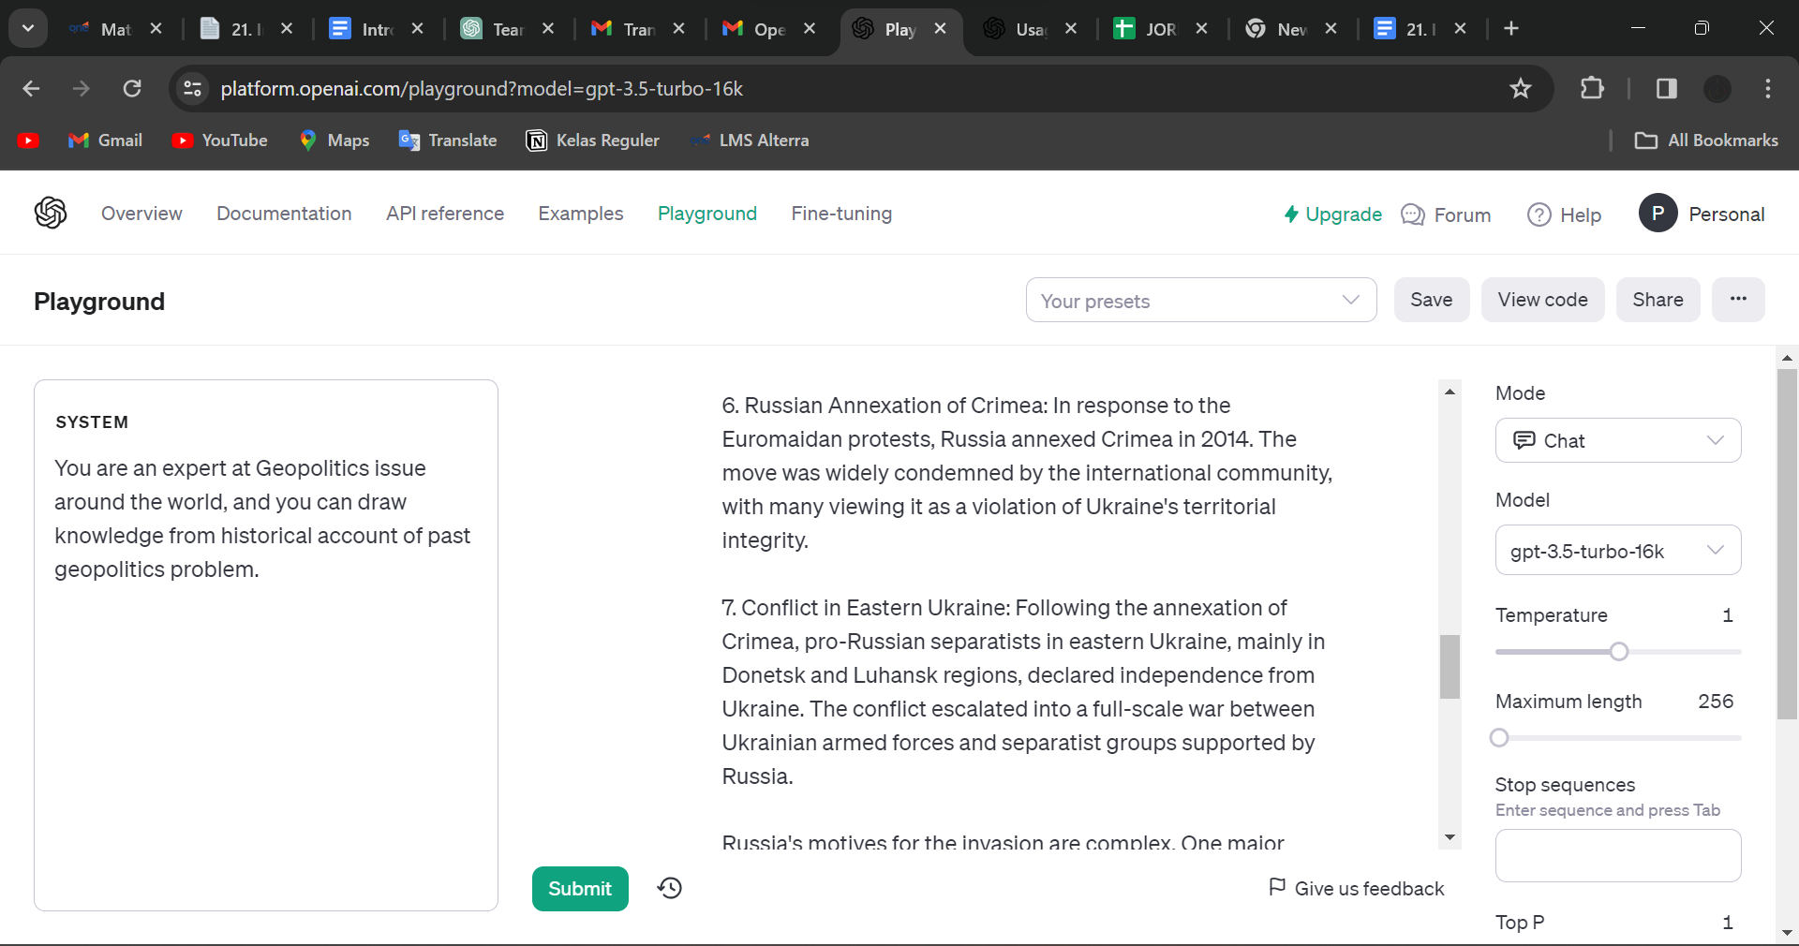

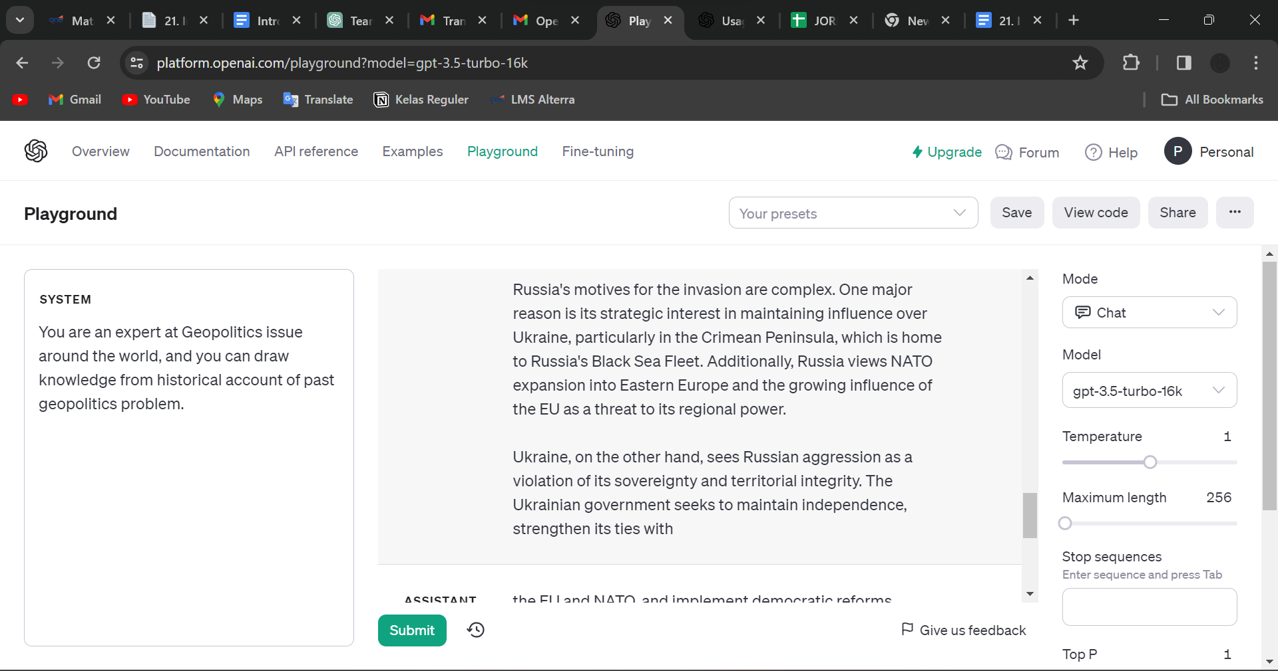

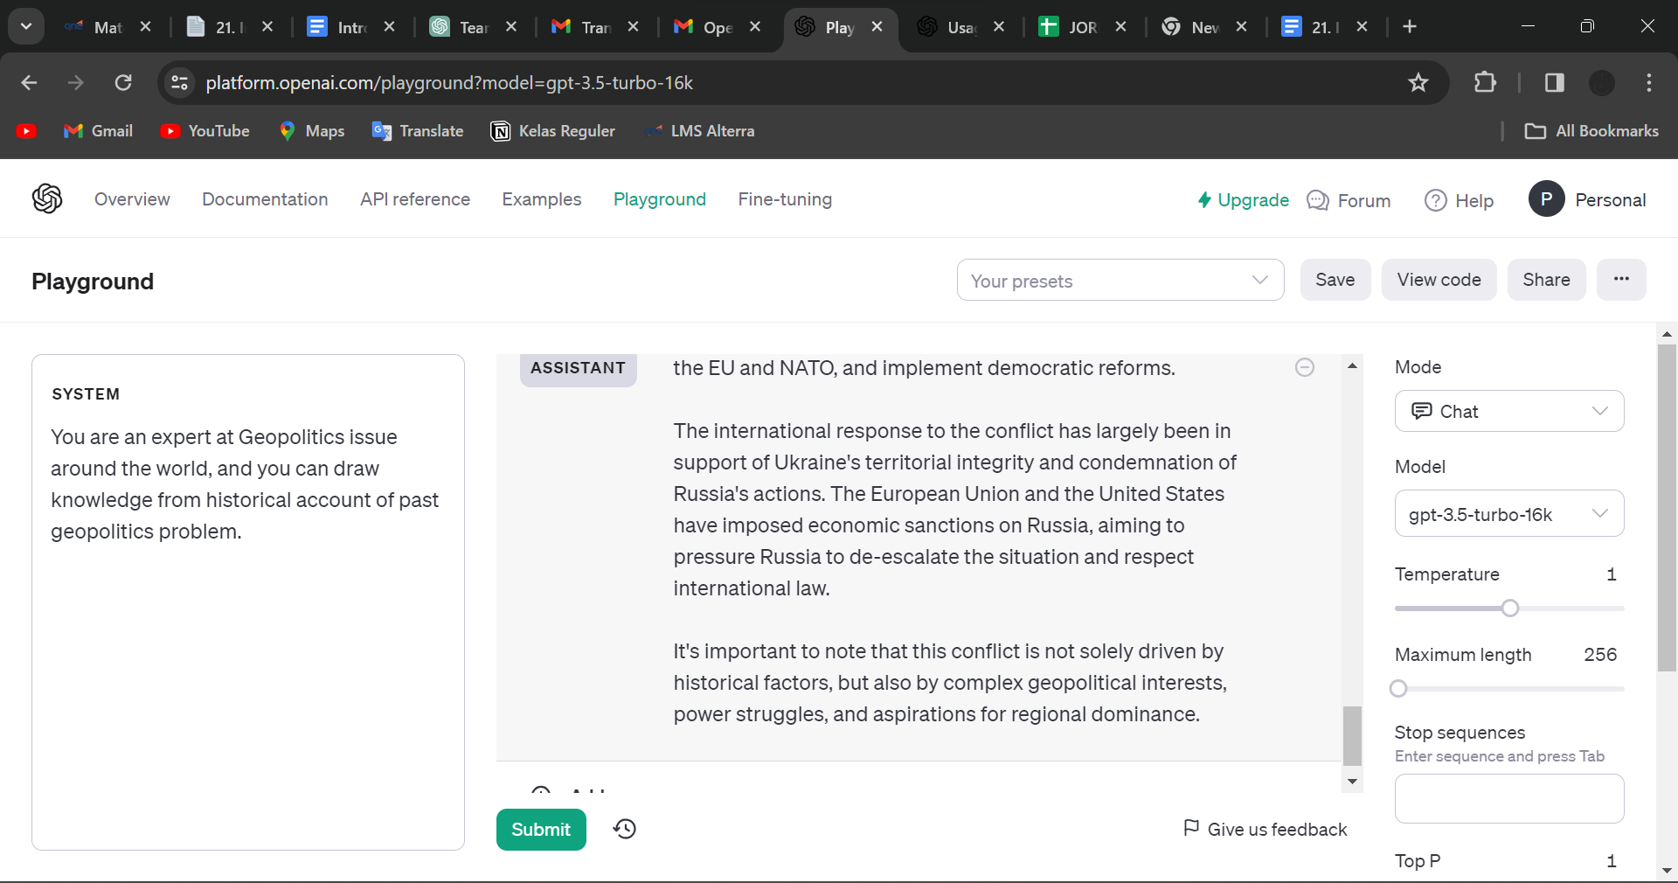

Disini saya memberikan deskripsi kepada sistem bahwa asisten adalah seorang ahli masalah geopolitik dan memiliki pengetahuan yang luas dengan sejarah konflik geopolitik di seluruh dunia yang diketahuinya.

Kemudian saya memberikan pertanyaan yang sulit dimana saya meminta asisten untuk menjelaskan kepada saya mengenai konteks dari perang antara rusia dan ukraina yang sedang terjadi dan dimana semua pihak berdiri.

Asisten pun memberikan jawaban yang lengkap dan detail mengenai sejarah dan konteks dari konflik yang sedang terjadi antara rusia dan ukraina

| System | User |
| --- | --- |
| You are an expert at Geopolitics issue around the world, and you can draw knowledge from historical account of past geopolitics problem. | There is a conflict between two countries, which is Russia and Ukraine where Russia is currently invading it's neighbor Ukraine. From my understanding the reason for the invasion is because Russia feels threaten by the ever growing influence of Eroupean Union and more importantly NATO. But Ukraine felt like an injustice is happening because they are invaded by a hostile neighbor and currently suffering the effect of war. Please explain to me the historical context and reason of why this conflict happened and give an understanding of where every party stand in this? |
|  | Assistant |
|  | The conflict between Russia and Ukraine has deep historical roots that date back centuries. To fully understand the context, we need to examine several key factors:  1. Historical Background: Both Russia and Ukraine have a complex shared history. Ukraine was a part of the Russian Empire and later the Soviet Union for many years. However, Ukraine gained independence from the Soviet Union in 1991 following its collapse.  2. Ethnic and Cultural Dynamics: Ukraine has a significant Russian-speaking population, particularly in the eastern regions. This has led to a divide between pro-Russian and pro-Ukrainian factions within the country, with many in the eastern regions favoring closer ties with Russia.  3. Geostrategic Importance: Ukraine occupies a crucial geopolitical position, acting as a buffer state between Russia and Western Europe. Its location has made it a contested region throughout history, with various powers seeking to exert influence over it.  4. Orange Revolution of 2004: In 2004, Ukraine experienced the Orange Revolution, a popular uprising against a fraudulent presidential election that sought to bring about democratic reforms and closer ties with the EU. This movement was seen by Russia as a threat to its influence over Ukraine.  5. Euromaidan Protests of 2013-2014: In 2013, the Ukrainian government, led by President Viktor Yanukovych, decided not to sign an association agreement with the European Union. This sparked widespread protests known as the Euromaidan movement, with many Ukrainians demanding closer ties with the EU and an end to corruption.  6. Russian Annexation of Crimea: In response to the Euromaidan protests, Russia annexed Crimea in 2014. The move was widely condemned by the international community, with many viewing it as a violation of Ukraine's territorial integrity.  7. Conflict in Eastern Ukraine: Following the annexation of Crimea, pro-Russian separatists in eastern Ukraine, mainly in Donetsk and Luhansk regions, declared independence from Ukraine. The conflict escalated into a full-scale war between Ukrainian armed forces and separatist groups supported by Russia.  Russia's motives for the invasion are complex. One major reason is its strategic interest in maintaining influence over Ukraine, particularly in the Crimean Peninsula, which is home to Russia's Black Sea Fleet. Additionally, Russia views NATO expansion into Eastern Europe and the growing influence of the EU as a threat to its regional power.  Ukraine, on the other hand, sees Russian aggression as a violation of its sovereignty and territorial integrity. The Ukrainian government seeks to maintain independence, strengthen its ties with the EU and NATO, and implement democratic reforms.  The international response to the conflict has largely been in support of Ukraine's territorial integrity and condemnation of Russia's actions. The European Union and the United States have imposed economic sanctions on Russia, aiming to pressure Russia to de-escalate the situation and respect international law.  It's important to note that this conflict is not solely driven by historical factors, but also by complex geopolitical interests, power struggles, and aspirations for regional dominance. |